Ultrasonic Distance Sensor
What do the following parts of the distance sensor connect with?
- Vcc:
- Trig:
- Echo:
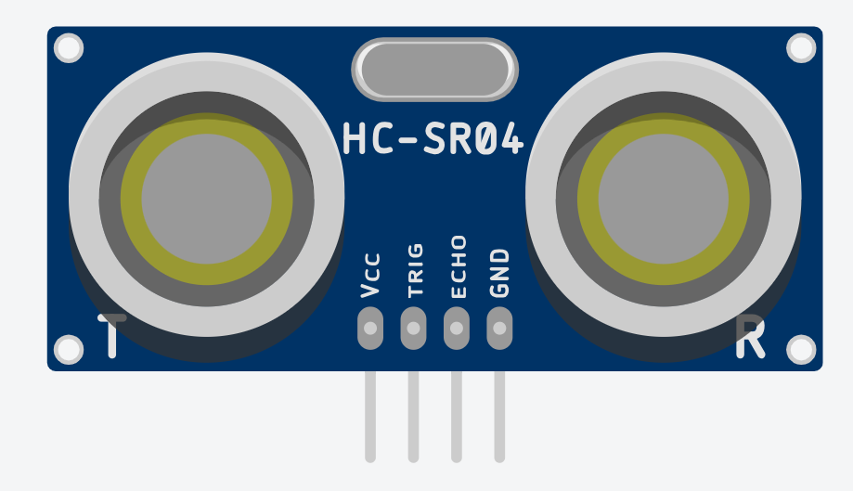
- GND:

Coding
What does this block do and how does it work?
______________________________________________________________________________________________________________________________________________________________________________________________________________________________________________________________________________________________________________________________________________________________
Sensor Range

Draw an empty circle inside the sensor’s range, and a shaded circle outside of the sensor’s range. The sensor will only be able to read the distance of the empty circle.

