Intro to Circuits
(Plan)
- Skills:
- Tinkercad
- Basic Arduino
- Circuits
- Breadboards
- Block coding
- Binary (challenge)
- Time: 30 mins-1.5 hours (depends on how long it takes students to complete and whether they do the challenge)
- Age: 10-14
- Materials:
- Computers (1 per student)
- Before the lesson:
- Create a Tinkercad classroom. This is not necessary but it will allow you to see what students make in one place and make starter designs which they can copy. Students will join using their emails.
- Once you have everyone's emails, you can send them join codes for the class
- If using a Tinkercad classroom, give them instructions on how to copy and tinker lessons
- Make the project in Tinkercad and experiment with a few ways to make it
- Understand how circuits work
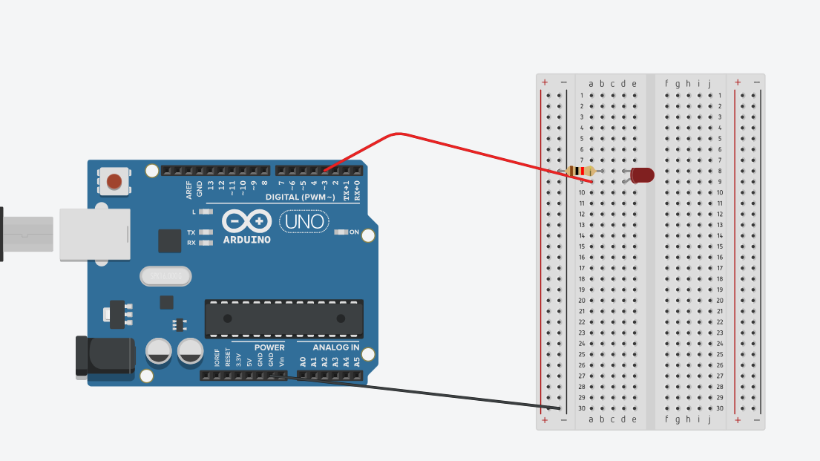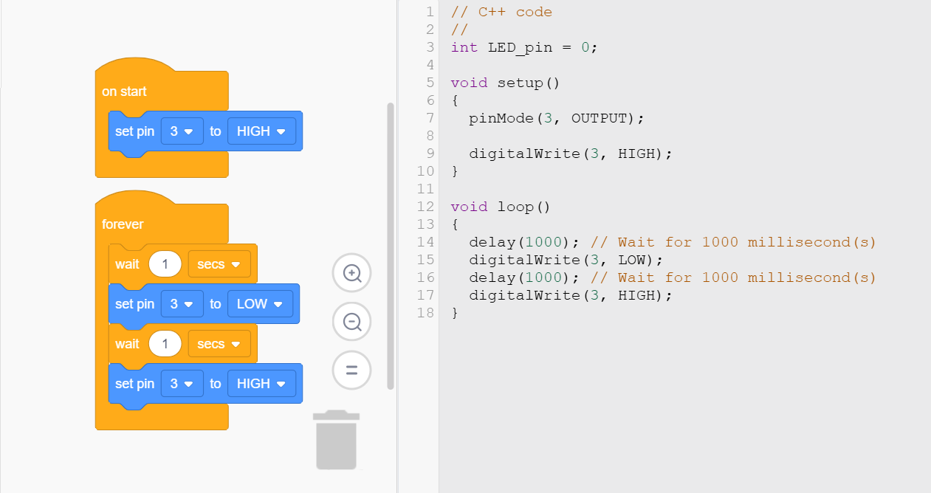
Final circuit example Final code example

Challenge code and circuit:

