Circuits:
The ______ side of a ____ is called a cathode. The ____ side is called an anode. Energy flows from _______ to ______ (the ______ to the ______). In an LED this means that the cathode must attach to the (short/long) side of the LED and the anode attaches to the (short/long) side.

Arduino parts:
Label parts of the Arduino that you have learned about and what you will use them for.
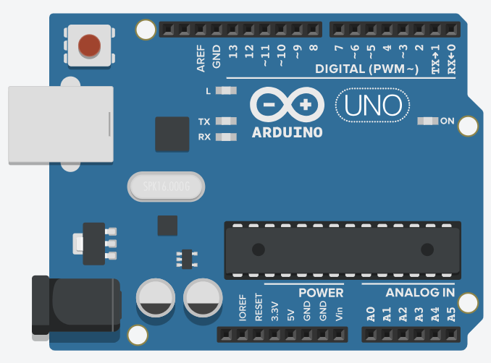

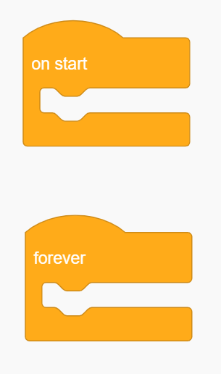
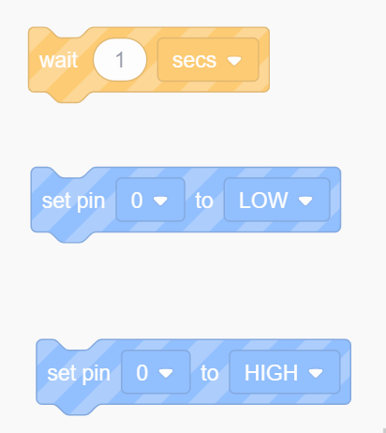
Block code (explain what these blocks do):
________________ ________________
________________ ________________
________________
________________
________________ ________________
________________ ________________

Binary practice:
Write the following binary numbers in decimal form:
1011 = 10011 = 011001 =
0110 = 01110 = 110110 =
0010 = 10101 = 001011 =

